Task 5 - Exploratory Data Analysis (EDA)
Objective
Perform Exploratory Data Analysis on the Titanic Dataset to identify patterns, trends, relationships, and anomalies using statistical techniques and visualizations.
Tools Used
- Python
- Pandas
- Matplotlib
- Seaborn
- Google Colab
Dataset
Titanic Dataset
Analysis Performed
- Data Inspection using info() and describe()
- Missing Value Analysis
- Histogram
- Boxplot
- Survival Count Analysis
- Gender vs Survival Analysis
- Passenger Class vs Survival Analysis
- Correlation Heatmap
- Pairplot
- Scatter Plot
Visualizations
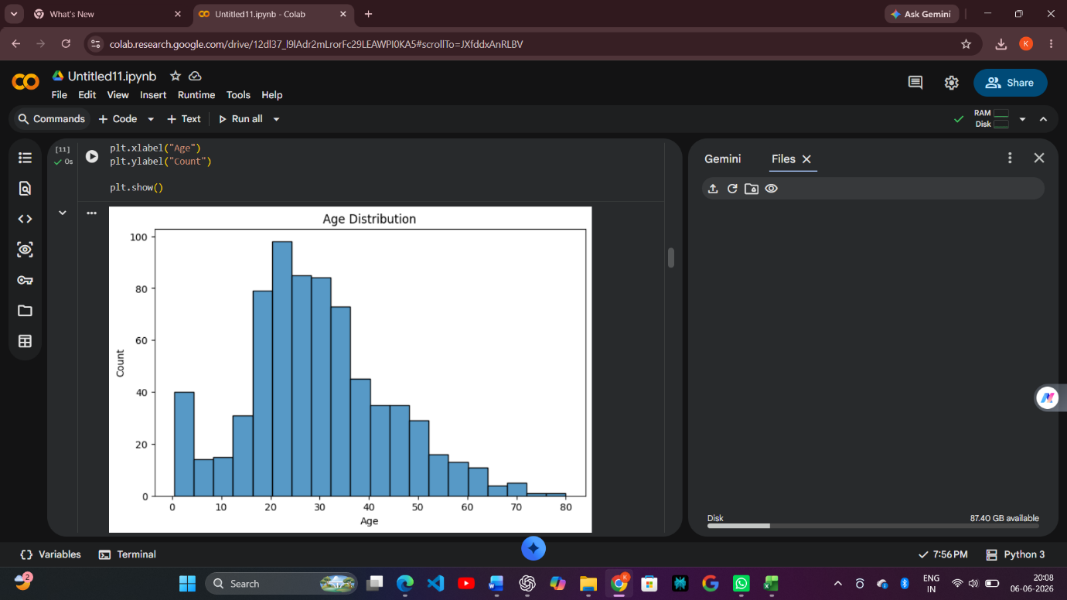
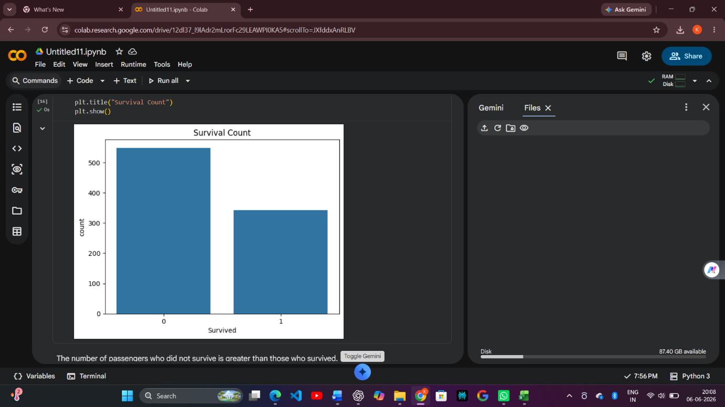
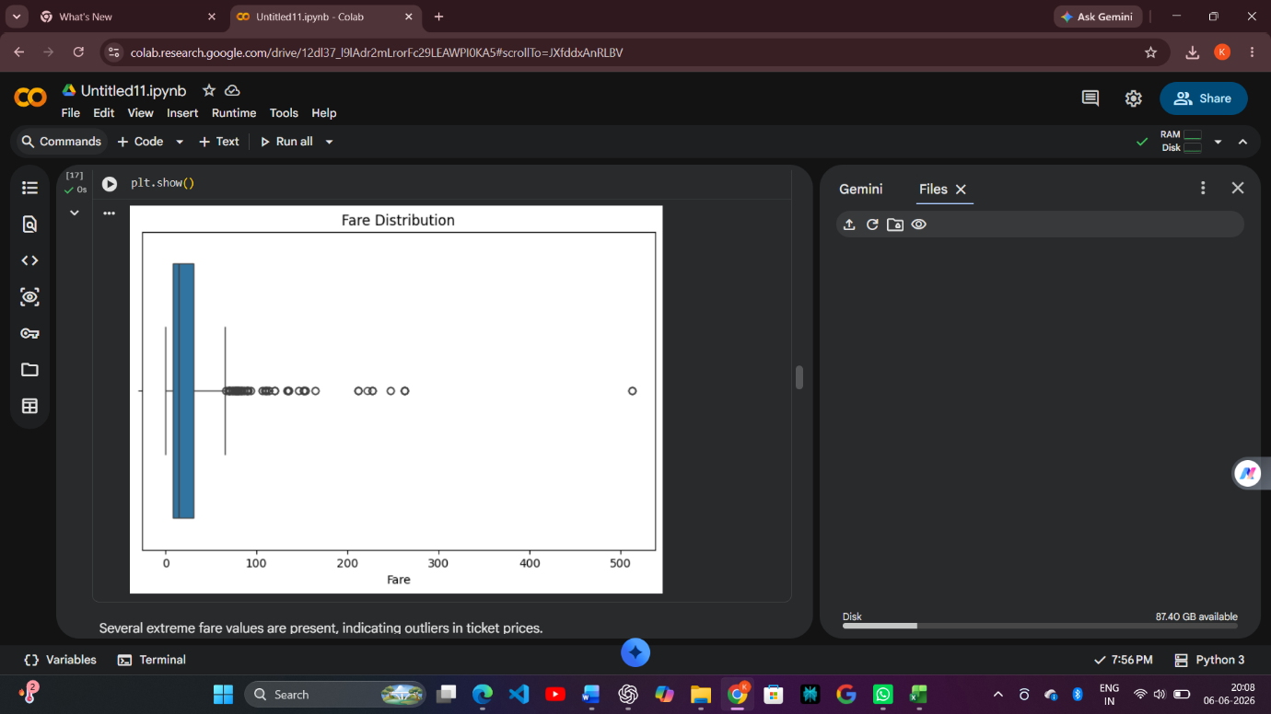
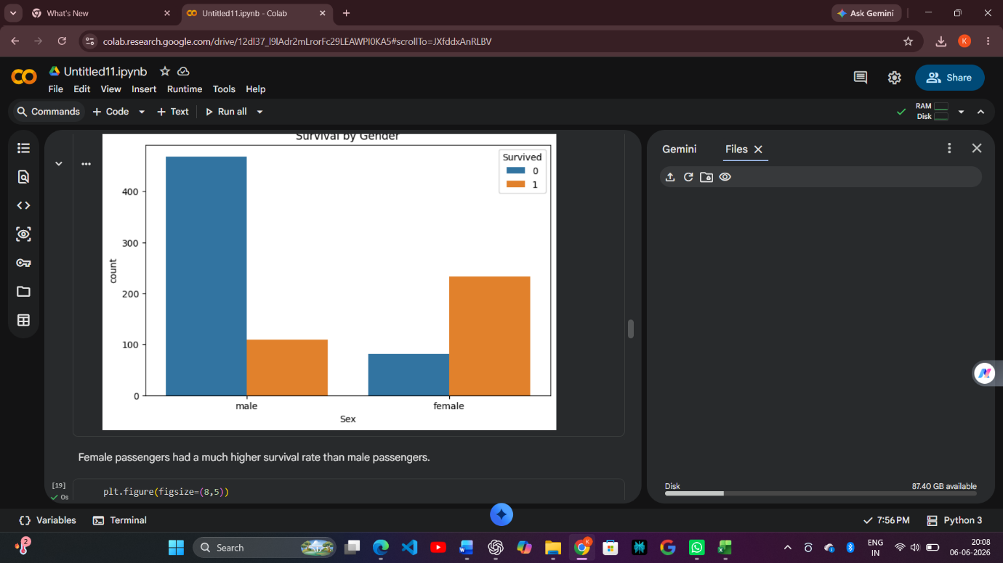
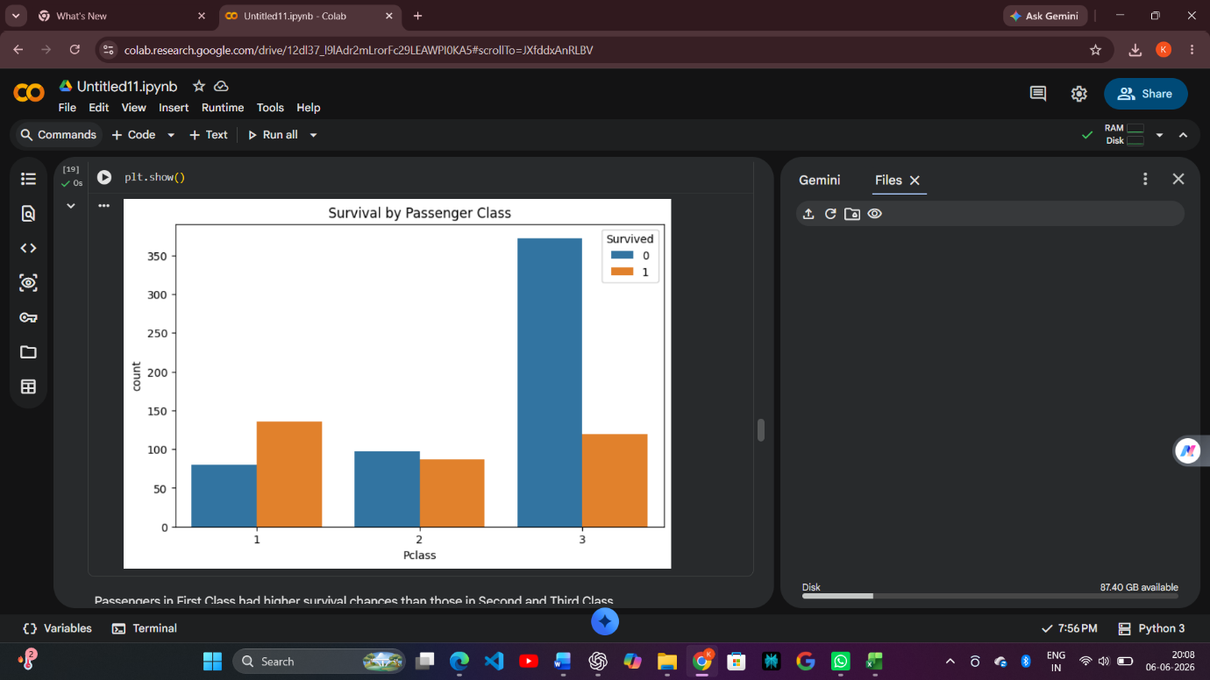
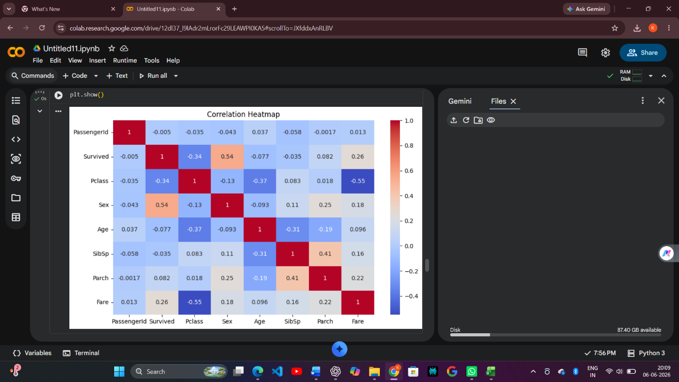
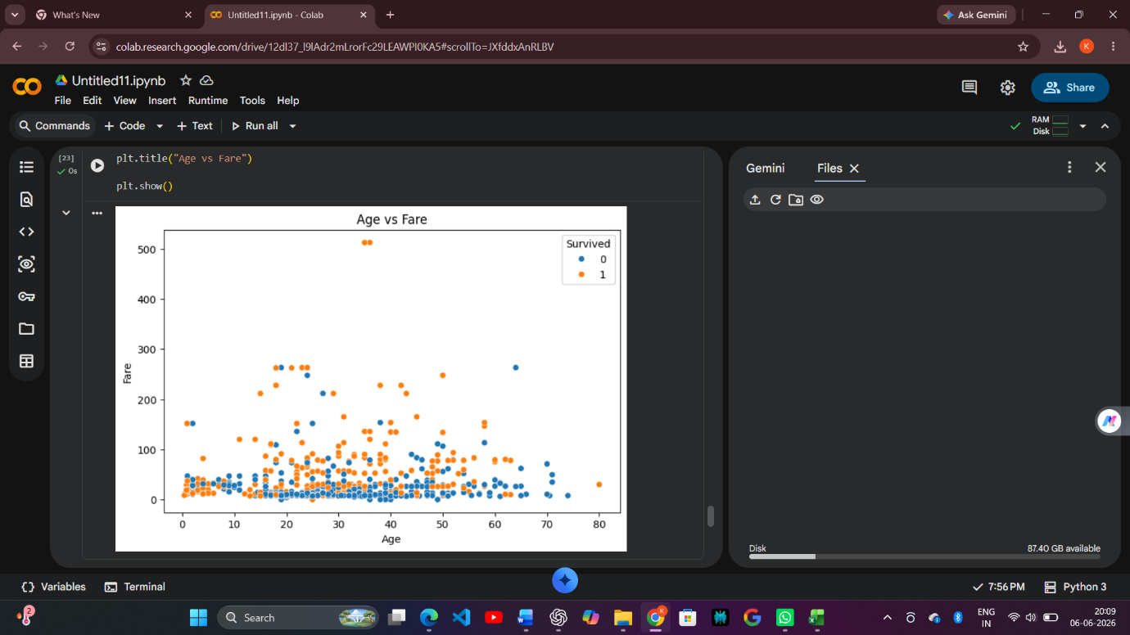
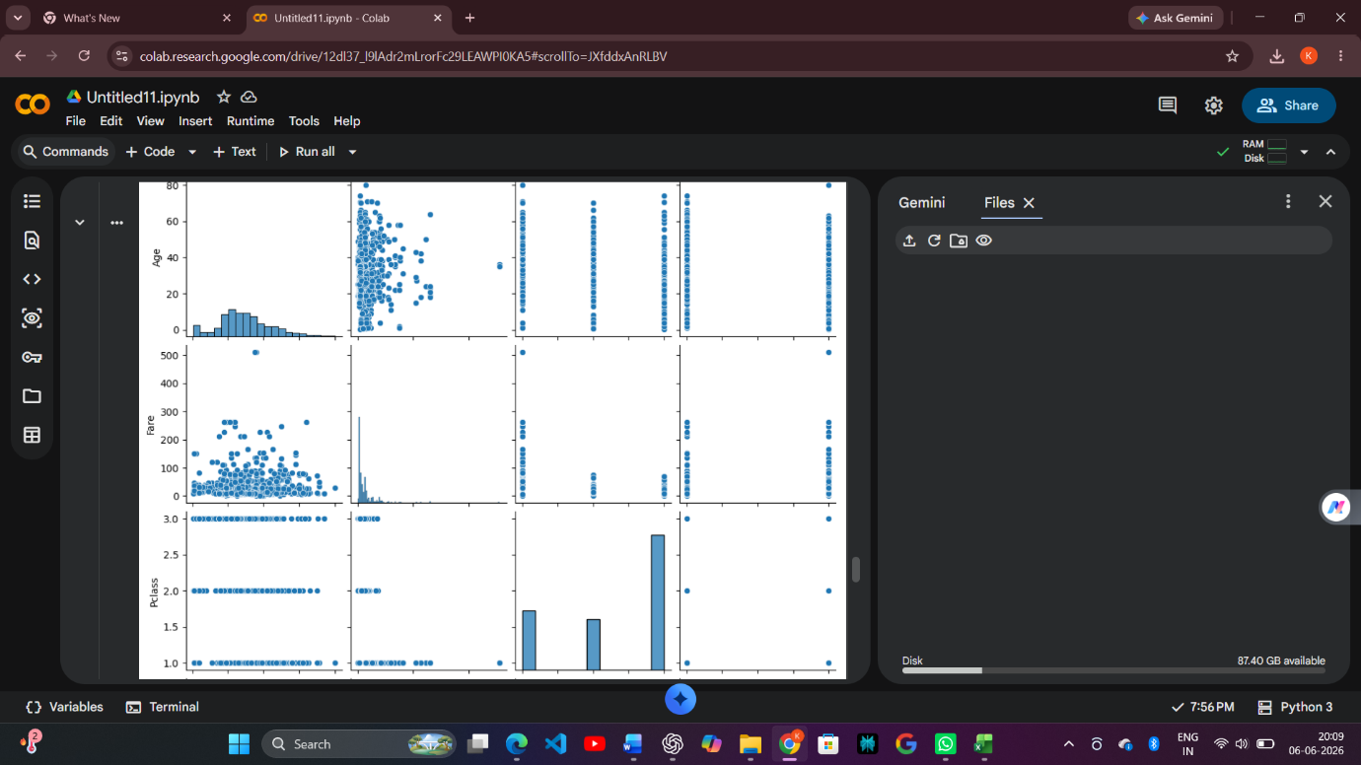

Key Findings
- Most passengers were between 20 and 40 years old.
- Female passengers had higher survival rates.
- First Class passengers survived more frequently.
- Fare contains significant outliers.
- Passenger Class and Fare strongly influence survival.
Outcome
Successfully explored the dataset, identified patterns and trends, visualized relationships, and generated meaningful insights through Exploratory Data Analysis.

